(Use https://markdownlivepreview.com/ to view and edit!)

Deliverables (all deliverables, this is the schedule):
- A schedule of concrete tasks (at most 4 hours per task) that represent all work required to finish your project along with task statuses
- Diagrams: database schema, class, layer, flow
- Wireframes: roughly sketch your UI and how one view transitions to another. You can also use design tools to create wireframes.
- A short presentation, 4 to 6 slides, describing who you are, how you found programming, and your project
- Complete project source code free of compiler errors
- A schema creation script along with any DML for data needed to run the application (security roles, default data, etc)
- If it isn't straight-forward, instructions to set up and run your application
- A complete test suite with all tests passing
TWO THINGS I NEED YOU GUYS TO DO:
Review and update the checklist. I’ve highlighted the parts that need to be filled in, but feel free to add other parts so we can power through this shit on Monday.
Create a file repository outline, I think she asked for one of those. Something like this:
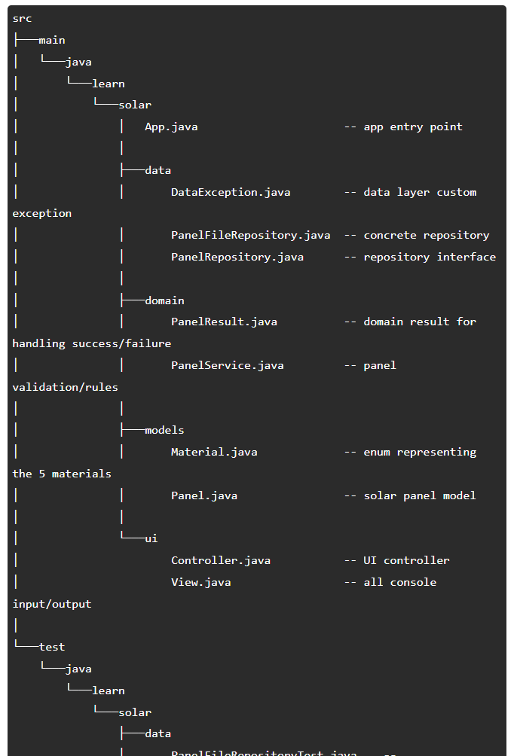

## Part 1: Server + SQL
### Data
* [ ] Create SQL schema based off of Database Schema
* [ ] Test SQL schema using HTTP methods
* [ ] Create corresponding Models in /src/main/java/[PROJECT_NAME]/models
* [ ] Create User Model
* [ ] Create Corresponding Mapper
* [ ] Create Corresponding Repository
* [ ] CRUD Operations
* [ ] Create Teacher Model
* [ ] Create Corresponding Mapper
* [ ] Create Corresponding Repository
* [ ] CRUD Operations
* [ ] Create Quiz Model
* [ ] Create Corresponding Mapper
* [ ] Create Corresponding Repository
* [ ] CRUD Operations
* [ ] Create Question Model
* [ ] Create Corresponding Mapper
* [ ] Create Corresponding Repository
* [ ] CRUD Operations
* [ ] Create Result Model
* [ ] Create Corresponding Mapper
* [ ] Create Corresponding Repository
* [ ] CRUD Operations
* [ ] Create Score Model
* [ ] Create Corresponding Mapper
* [ ] Create Corresponding Repository
* [ ] CRUD Operations
* [ ] Test created Repositories

### Domain
* [ ] Create Services and corresponding methods for each Model/Repository
* [ ] Create User Service
* [ ] Generate authorization key
* [ ] Validate username and password
* [ ] Create Teacher Service
* [ ] Be able to create, edit, delete Quizzes
* [ ] View scores by quiz
* [ ] Create Quiz Service
* [ ] Quizzes need to have the user logged in to be taken.
* [ ] Validate teacher_id, title and description
* [ ] Create Question Service
* [ ] Validate quiz_id and question_text
* [ ] Create Result Service
* [ ] Validate user_id, quiz_id, question_id, option_id.
* [ ] Create Score Service
* [ ] Validate user_id, quiz_id, score
* [ ] Calculate score based on results from user_id
* [ ] Test created Services

### Controllers
* [ ] Create Controllers and corresponding methods for each Service
* [ ] Create User Controller
* [ ] Create Teacher Controller
* [ ] Create Quiz Controller
* [ ] Create Question Controller
* [ ] Create Result Controller
* [ ] Create Score Controller

* [ ] Test created Controllers
* [ ] GET
* [ ] POST
* [ ] PUT
* [ ] DELETE

## Part 1.1: Implement AI model API
* (Currently undefined, will research over the weekend.)
* (Corresponds with a Quiz, most likely in the Data layer.)
* (Creates Questions, Objects from JSON)

* Quiz Parameters:
* Multiple Choice
* 2 < x < 10 answer options (will adjust after discussion)
* 1 < y < 50 questions (will adjust after discussion)
* Must validate returned JSON object so that it returns a usable JSON object:
* Current version of the prompt:
* "Create for me a quiz in a JSON format.
* The quiz must be multiple-choice.
* It must be (NUMBER INPUT) questions long with (NUMBER INPUT) options for each question.
* The quiz must be about (TEXT INPUT - "Topic").
* The format must contain a "quiz" object with two nested objects, "title" and "questions".
* "title" is a string value on the topic of the quiz.
* "questions" is an array containing individual questions.
* Each question in the "questions" array is made up of three parts:
* "question", a string containing the question itself
* "options", an array containing answers as a string
* "correct_answer", string representing the correct answer
* Do not include an explanation before or after the JSON code."

## Part 2: Client
### React
* [ ] Create new React project with create-react-app
* [ ] Remove unnecessary files

* [ ] Add Bootstrap
* [ ] Add a link to the Bootstrap CSS using the
[CDN from the official docs](https://getbootstrap.com/docs/4.6/getting-started/introduction/#css)
* [ ] Add the [`container` CSS class](https://getbootstrap.com/docs/4.6/layout/overview/#containers) to the `<div id="root"></div>` element

*[ ] Components and Routing
[ ] Create Quizzes component
* Update the APP component to render the QUIZZES component
*Set up basic routing between components (login, dashboard, quizzes, etc.)
[ ] Update Quizzes to render a list of available quizzes
*Use FETCH to GET a list of quizzes from the Quiz API when the component is first loaded
*Write JSX to render the quizzes array
*Use event handlers for "Take Quiz", "Edit Quiz", and "Delete Quiz"

*[ ]Student Flow
[ ]Login Page
*Create a login form with username and password fields
*Add onSubmit event handler to authenticate the user
*Redirect user to appropriate dashboard after login
[ ]Student Dashboard
*Display the available quizzes for students
*Add a button to “Take Quiz”
*Use FETCH to GET the list of quizzes the student can take from the Quiz API
[ ] Take Quiz Form
*Display quiz questions and multiple-choice options fetched from the API
*Add ONSUBMIT event handler to submit quiz answers
*Display confirmation after successful submission of the quiz and calculation of the score
[ ] View Scores
*Display the student’s quiz scores fetched from API

* [ ] Teacher Flow
[ ] Teacher Dashboard
*Add buttons for creating a new quiz, viewing/editing/deleting, and viewing/resetting scores
*Use FETCH to GET a list of all quizzes created by the teacher from the Quiz API
[ ] Create a Form to Add a Quiz
*Add form fields for number of questions, number of options, and quiz topic
*Add onChange event handlers to input elements
*Add onSubmit handler to form to request quiz from API
*After successful quiz creation, update quizzes array or display errors
[ ] Support Deleting Quizzes
*Confirm deletion
*Use FETCH to DELETE quiz from backend DB
*update the quizzes array in the state (don’t modify original)( if successful)
[ ] Edit Quiz Form
*Add form to edit quiz questions and options
*Fetch quiz data using GET when component is first loaded
*Add onSubmit event handler to submit changes via PUT
*On success, redirect to the Teacher Dashboard or show errors
[ ] View and Edit Score
*Display all student’s scores for a select quiz
*Add a button to edit scores (maybe)

### Different Views
* [ ] Login Page (STUDENT/TEACHER):
*Title: Quick Quiz Login
*Username Input Field
*Password Input Field
*Login Button
*Sign Up Link (optional)
* [ ] Teacher Dashboard (After login as TEACHER):
*Title: Teacher Dashboard
*Options:
*Create New Quiz Button
*View/Edit/Delete Quizzes Button
*View All Scores Button
*Reset Scores Button
* [ ] Student Dashboard (After login as STUDENT):
*Title: Student Dashboard
*Options:
*Take Quiz Button (Shows Available Quizzes)
* [ ] Create Quiz Page (For TEACHER):
*Title: Create a New Quiz
*Fields:
*Input for Number of Questions (Number field)
*Input for Number of Options per Question (Number field)
*Input for Quiz Topic (Text field)
*Generate Quiz Button (Sends inputs to AI for generating the quiz)
* [ ] Edit Quiz Page (For TEACHER):
*Title: Edit Quiz
*Display Existing Quiz in Table Format:
*Editable Questions & Options Fields (Allow text input/edit)
*Save Changes Button
*Delete Quiz Button
* [ ] View Quiz Page (For STUDENT):
*Title: Take Quiz
*Quiz Display:
*Questions Listed (in table or card format)
*Multiple Choice Answer Options (Radio buttons)
*Submit Quiz Button
* [ ] View Scores Page (For STUDENT/TEACHER):
*Title: Quiz Scores
*Display:
*Quiz List for Teacher to View All Scores
*Student can see their own scores
* [ ] Reset Scores Page (For TEACHER):
*Title: Reset Scores
*Display:
*List of Students and their Quiz Scores
*Reset Button next to each student’s score

